**1.**

**2.**

**Tiến trình cài đặt**

**2. Cài NetBeans**

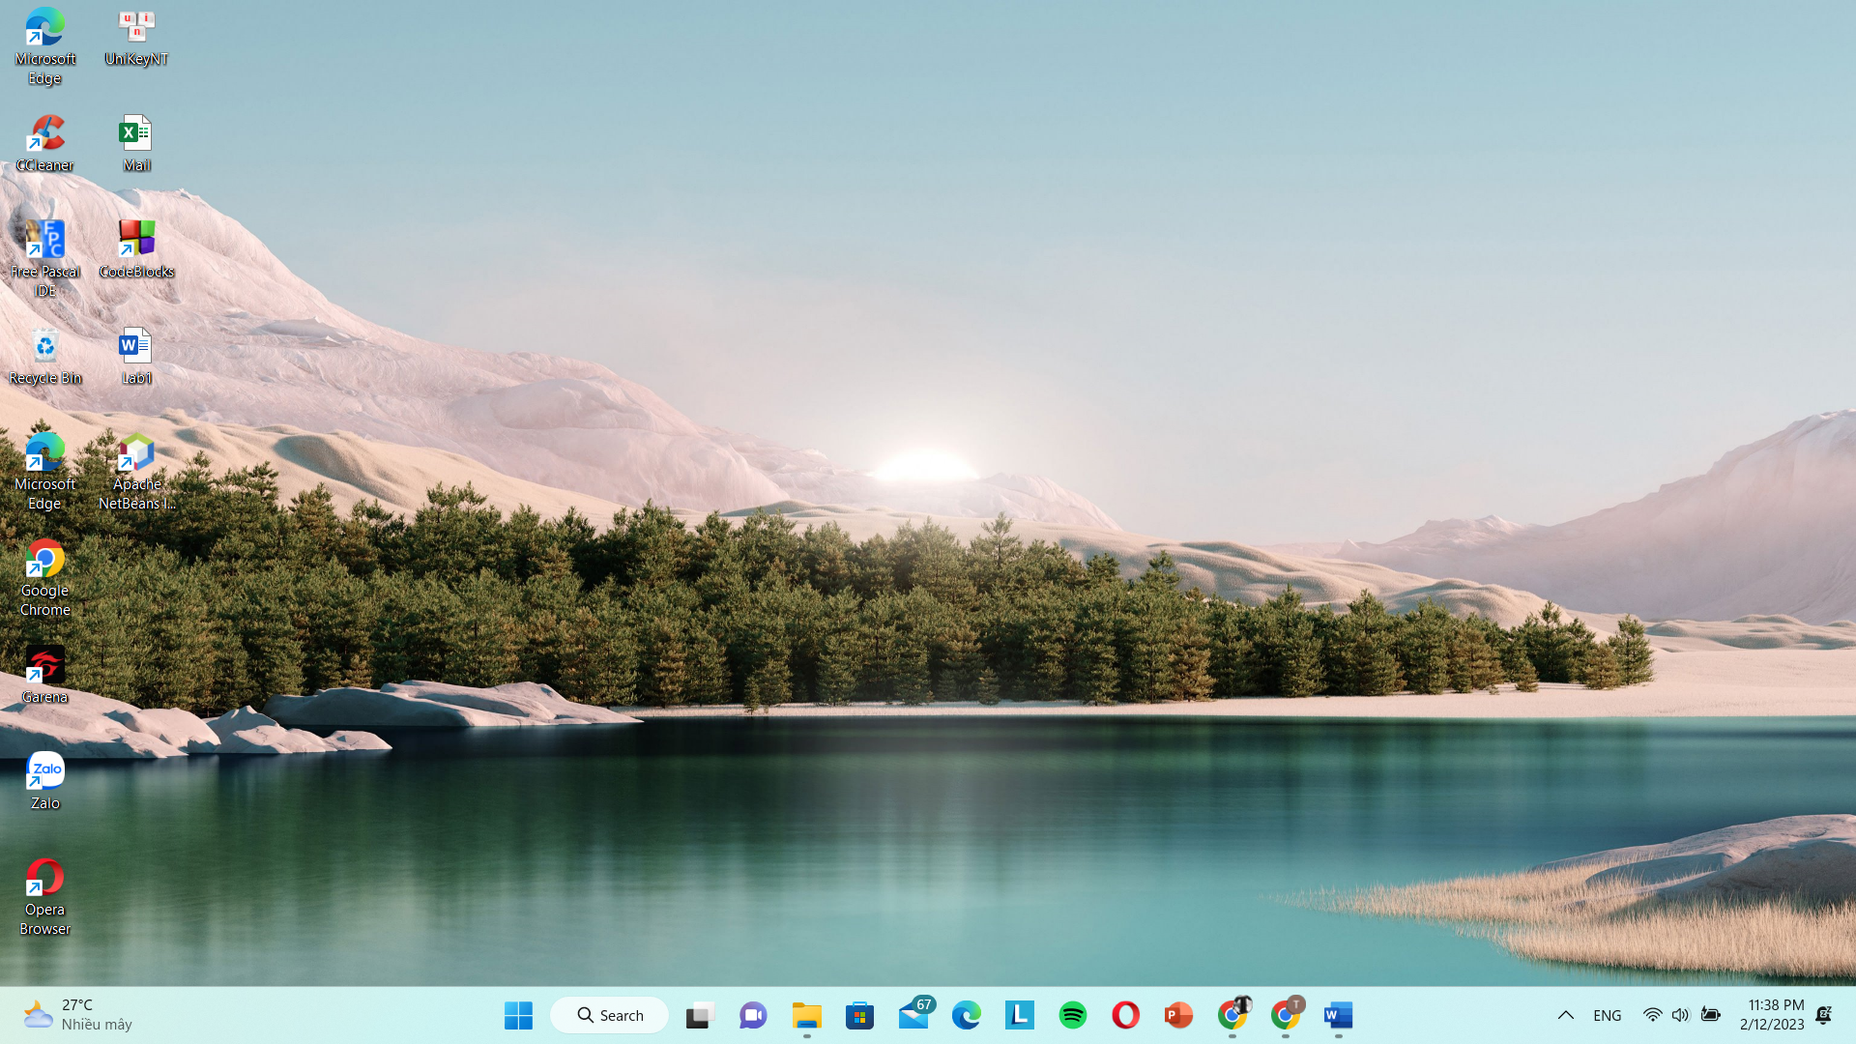

**Thiết lập môi trường**

**Hướng dẫn sử dụng Apache**



